Functional Specification

Best Practices

Table of Contents

1 PERMISSION CONTROL 2

2 LANDING PAGE STRUCTURE 2

2.1 HEADER 3

2.2 FILTER BAR(ORANGE BAR) 3

2.3 EXAMPLES LIST 3

2.4 FEATURED CAMPAIGN SHOWCASE 4

3 DETAIL PAGE STRUCTURE 5

3.1 HEADER 6

3.2 EXAMPLE DETAILS 6

3.3 OTHER BEST PRACTICE EXAMPLES 7

3.4 AGENCY/INTERNAL TEAM INFORMATION 7

4 BEST PRACTICE EXAMPLES MAINTAINENCE 7

5 DIFFERENCES BETWEEN OMOBONO’S DESIGN AND OUR WORK 7

# PERMISSION CONTROL

* All login users can view this page
* Only Brand team members can maintain best practices examples in backend

# LANDING PAGE STRUCTURE

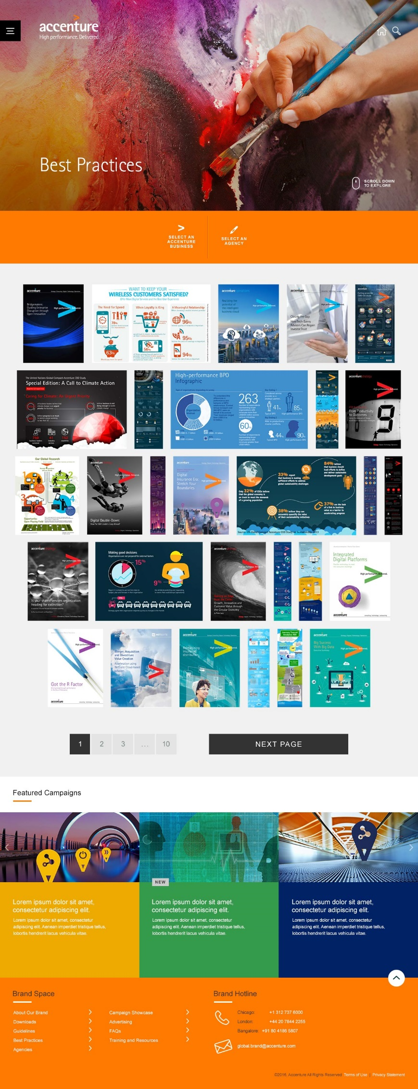

Best practices landing page is consist of below sections:

* Header
* Filter bar(Orange bar)
* Examples list
* Featured Campaign Showcase
* Footer

## HEADER

Follow the same style through the whole site, title text is “Best Practices”

## FILTER BAR(ORANGE BAR)



There are two filters: “SELECT AN ACCENTURE BUSINESS” and “SELECT AN AGENCY”.

Click one filter option will open its options list





The option values in each filter depend on what examples in the result list, for example, if there is no Accenture Consulting examples in the list, then “Accenture Consulting” will not be included in the the Accenture business options.

If use clicks one option value, that option will be displayed in the “SELECTED FILTERS” panel, and there is one “CLEAR ALL” button which allows user clear the selected filters.



## EXAMPLES LIST

The examples list lists all the best practice examples which meet the filtered criteria. All the examples are listed order by the uploaded date, newly uploaded ones will be on the first place.

It displays 30 examples per page, and there is the pagination under the examples list which allows users go to different page of the search result.

Each example tile is displayed with its preview image thumbnail, click it will go the example’s detail page

## FEATURED CAMPAIGN SHOWCASE

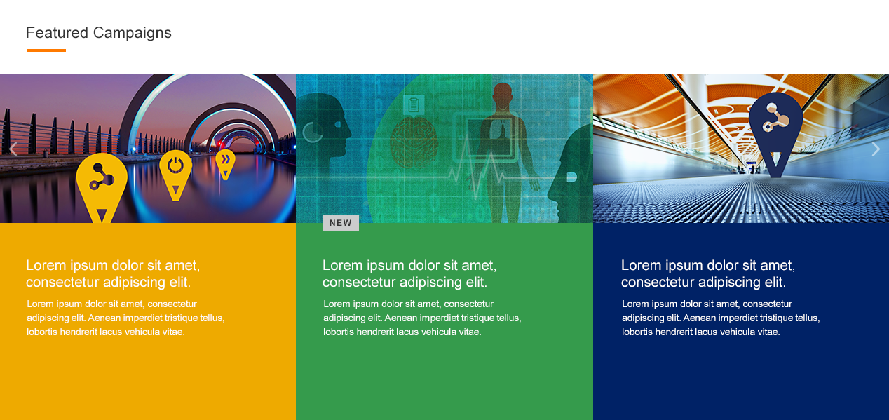

This section pulls 12 showcase randomly from the featured campaign showcase pool, and disply them as a carousel. Each showcase tile is consist of below elements:

* The hero image thumbnail on the top
* The showcase title and description with white color font, and its backgrnd showcase’s primary color
* If the showcase was approved in rencent two weeks, then there will be a “NEW” label

Hover the showcase tile the background color will be changed to white and font color will be changed to black(#333333).

# DETAIL PAGE STRUCTURE

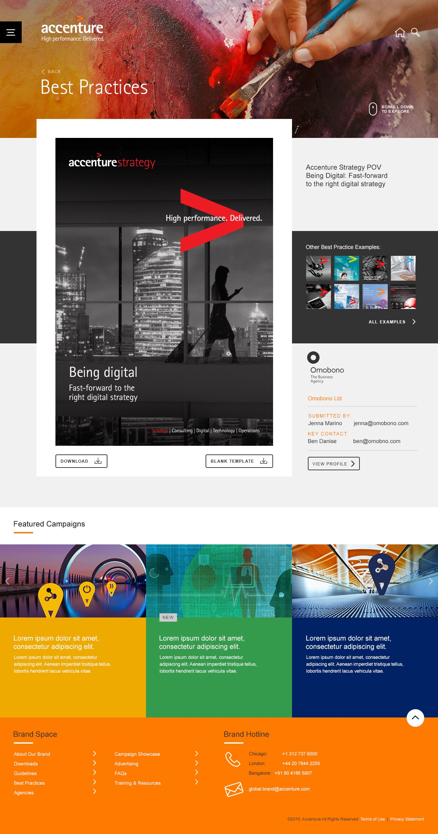

This page is consist of below sections:

* Header
* Example details
* Other Best Practice Examples
* Agency/Internal Team information
* Featured Campaign Showcase
* Footer

## HEADER



Follow the same style through the whole site, this page’s header is a shorter header which height should be 30% of screen’s width(default is 50%), title text is “Best Practices”, click the “BACK” link will take user to best practices landing page and previous search result will be displayed

## EXAMPLE DETAILS

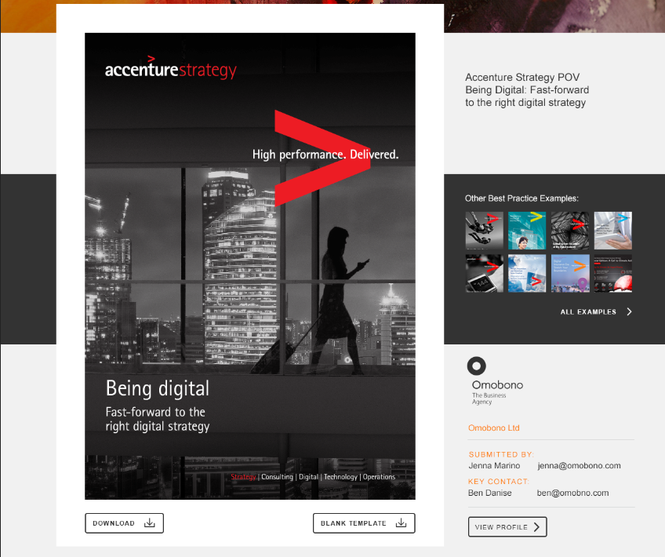

This section includes below parts:

* Preview image of the example
* A DOWNLOAD button, click it will download one zip file which includes related files for this example
* If this example has one related template, there will be a “BLANK TEMPLATE” download button, click it will download the template
* Example’s title

## OTHER BEST PRACTICE EXAMPLES

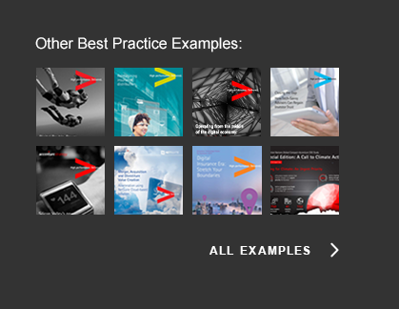

This section pulls 8 related examples randomly from the best practices pool, related examples are the ones which use the same template as current displayed example. Each example is displayed as a square tile with its preview image. Click each tile will take user to that example’s detail page. Click “ALL EXAMPLES” link will take user to the best practices landing page.

If current displayed example doesn’t use any template, then nothing will be displayed in this section.

## AGENCY/INTERNAL TEAM INFORMATION

If the example is from agency, then agency’s information will be shown as below screenshot

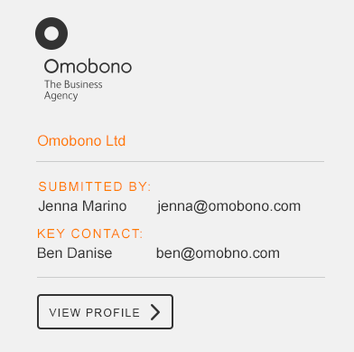

* The logo and agency name are populated from agency’s profile automatically
* Submitted by and key contact are input when add the example
* Click “VIEW PROFILE” button will take user to the agency’s profile page

If the example is from Accenture internal team, then team’s information will be shown as below screenshot



* Accenture logo will be used for internal team’s example
* Internal team name, submitted by and key contact are input when add the example

# BEST PRACTICE EXAMPLES MAINTAINENCE

Brand team can add/edit/delete any examples in the backend

# DIFFERENCES BETWEEN OMOBONO’S DESIGN AND OUR WORK

In Omobono’s design, in the search result list, click one example’s tile will open a dropdown panel which include more information of the example, and click the zoon icon  will open the detail page. But as confirmed with Kira, we don’t need to have this dropdown panel, but click the example’s tile will go to the detail page directly.

